AP Worldipedia Web Hunt – Unit 2
Directions: Go to the website www.apworldipedia.com for help with the Unit 2 review packet questions and tasks. Use the Unit 2 Key Concepts as a guide to help you navigate the information in the website. All Key Concepts are listed in your syllabus!
1. Label the following classical states and empires:
-Persian -Greek city-states
-Qin -Han
-Mauryan -Gupta
-Phoenicia -Hellenistic Empire (Alexander)
- Mayan City-states -Roman Empire
- Moche culture region

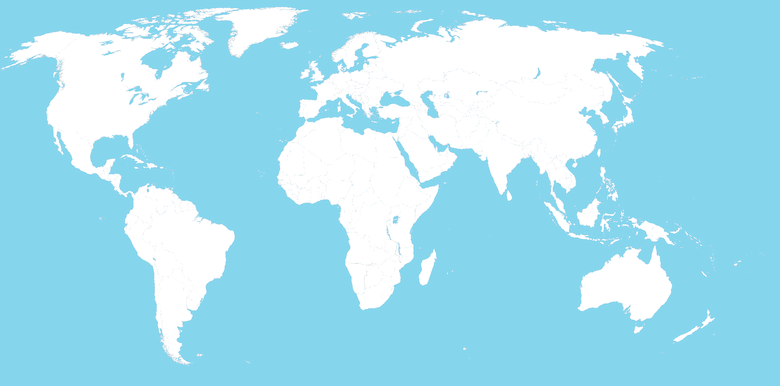

2. How did the Qin dynasty influence the Han dynasty?

3. List three examples of centralized states and two examples of decentralized states in the classical period.

4. Ashoka relied on what two things to rule the Mauryan Empire?

5. A classical empire’s ability to expand and maintain power over large areas was dependent in part on the projection of power and military might. List six techniques used to extend empire, project power, and maintain control:

6. List four common elements when comparing the fall of the Roman, Han, Persian, Mauryan, and Gupta empires:

7. Create a map showing the path of the Hun migrations/invasions:

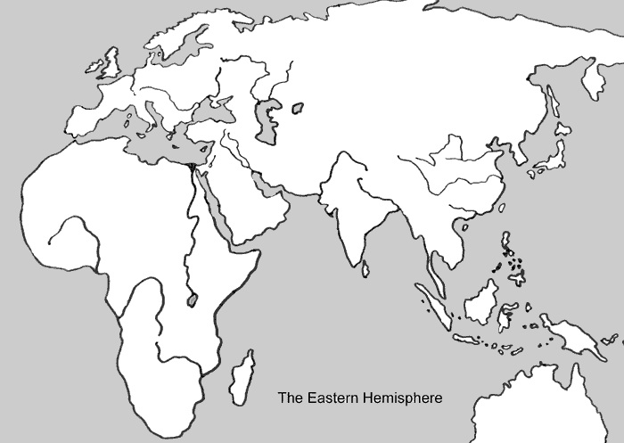

8. What were the Parthian and Sassanid empires?

9. List four new technologies or developments that facilitated long-distance communication and exchange in the classical era.

10. How did relics and stupas aid the spread of Buddhism?

11. Create four simple sketches showing common architectural styles of the classical age:

- Greek –

- Roman –

- Indian –

- Mayan –

12. What role did disease play in growing trans-regional networks of exchange?

13. Draw an illustrated map showing Silk Road trade routes, goods traded, cities, and civilizations and peoples involved in the trade.

14. On this same map, chart the early Indian Ocean trade network. Include what was traded and cities and empires involved in the trade.

15. How did weather impact Indian Ocean trade?

16. When did Mediterranean trade reach its peak?

17. What facilitated the spread of Christianity in the Roman Empire?

18. What is the qanat system, where did it first develop, and to where did it spread?

19. What is the Bhakti branch of Hinduism? How does it reflect change in the Hindu religion?

20. Describe Mahayana and Theravada Buddhism. How are they different? Why did Mahayana Buddhism develop, and why was it so appealing to the masses?

21. Buddhism’s decline in India was accompanied by (or replaced by) what?

22. What was one main divisive argument among early Christians?

23. Who were the Nestorians?

24. Why did the Frankish king Clovis convert to Christianity (in the 5th century C.E.)?

25. What role did the Phoenicians play in the establishment of the Mediterranean trade network?

26. What were the main items traded in the Mediterranean Sea trade network?

27. Trans-Saharan trade was just beginning in the late classical era, and would flourish in later centuries, during the post-classical period. What facilitated the start of this trade network, and what were the main items traded?

28. What existing religious traditions were further codified and developed during the classical era? (Give two examples)

29. What NEW beliefs and philosophies emerged in the classical era, between 600 BCE – 600 CE? (Give six examples)

30. Where would Shamanism and Animism be found in the classical era?

