Islamic Gunpowder Empires: A Comparison

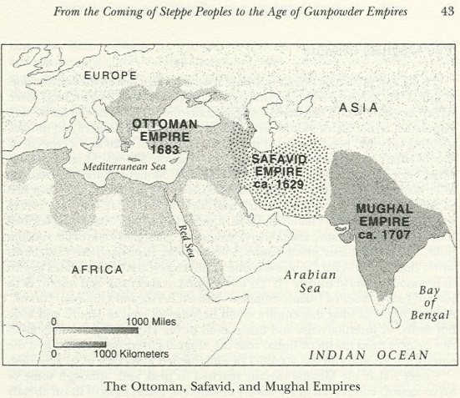
Common Elements:
- Nomadic Turkish conquerors
- Muslim piety a sign of legitimacy (Sufi influence on leadership was a commonality)
- Autocratic rule
- Imperial family politics often involved deadly competition – succession problems plagued all three empires
- Influence of women within the Imperial family in spite of lack of public power for women
- Use of jizya tax on dhimmi (protected non-Muslim) populations (though this was abolished for a time in the Mughal Empire.)

Decline:

- Entrenched aristocracy replaces meritocracy.
- Religious tension: conservative religious groups sometimes did not like policies that fostered tolerance of religious differences
- The rise of the West and new global economic competition led to eventual loss of tax revenues
- Cost of warfare and bureaucracies
- Failure, sometimes deliberate, to maintain technological development

 | Ottoman |  | Safavid | Mughal
Founding | 1289 – Osman Bey |  | 1501 – Shah Ismail (r. 1501-1524) | 1526 – Babur “the Tiger” (r. to 1530)
Islam | Sunni  Wahhabi (Arabian) |  | Twelver Shiism  Sufi | Akbar’s “divine faith”  Aurangzeb: Sunni
Origin | Anatolia between Black Sea and Mediterranean |  | Iran (Tabriz) | N. India (Kabul/Qandahar)
Largest Expanse | Yugoslavia/Greece, N. Africa, MidEast to Tigris River, Black Sea |  | Central Asia, from Tigris river to Gandahar, Caspian Sea to Persian Gulf and Indian Ocean | Most of India, except southern tip
Significant Dates | 1453 – Capture of Constantinople; renamed Istanbul |  | 1514 – Battle of Chaldiran (vs. Ottomans)
Military Institutions | ghazi “sword of God”  Janissaries – devshirme slaves in the army and bureaucracy |  | qizilbash (“red heads”)  “slaves of the royal household”
Great Leaders | Mehmed II “The Conquerer” (r. 1451-1481)  Süleyman the Magnificent (or “the Lawgiver”) (r. 1520-1566) |  | Shah Abbas “the Great” (r. 1588-1629) | Akbar (r. 1556-1605)  Aurangzeb (r. 1659-1707)
Cultural Monuments | Topkapi palace  Süleymaniye mosque complex (Istanbul) |  | Isfahan (capital city) | Taj Mahal (c. 1650)
Population | Entire Empire  1500 – 9M  1600 – 28M  1700 – 24M  1800 – 24M | Anatolia  1500 – 6M  1600 – 7.5M  1700 – 8M  1800 – 9M | 1500 – 5M  1600 – 6M  1700 –  1800 – 8M | 1500 – 105M  1600 – 135M  1700 – 165M  1800 – 190M
Religious Minorities | millet system: Christians, Jews. |  | Zoroastrians, Jews, Christians | Toleration varies: Hindus, Jains, Zoroastrians, Christians, Sikhs
Exports | Silk, Spices |  | Silk, carpets, ceramics, crafts | Pepper, jewels, metal craft goods
Vices | Tobacco, Coffee
End | End of World War I (1919) |  | 1722, mostly absorbed by Ottomans | late 18c, mostly absorbed by British

