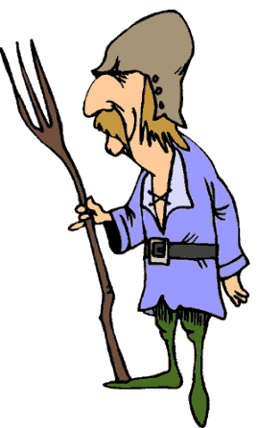
Meldon the Serf’s
Medieval Website Search
http://www.uncp.edu/home/rwb/lecture_mid_civ.htm
- On the map showing Justinian’s Byzantine empire in 565 CE, who was ruling Persia?
- What kingdoms were founded by Western Slavs?
- Why were the kingdoms of Hungary, Poland, and Bohemia more closely tied to Western Europe?
- The civilization of Kievan Rus developed along what River?
- Why was the rise of Moscow possible?
- Why did the Carolignian ruler Pepin and the Roman Church make an alliance in the 700’s? What did each get out of the deal?
- What was the “Carolignian Renaissance?”
- When did feudalism officially emerge, and why?
- What new power sources developed around 1000 CE?
- Why did urban life begin to revive in the 11th century?
- What was the bourgeoisie, and why didn’t they really fit in the old feudal system?
- What national monarchies began to rise in the high middle ages? Where did they NOT arise?
- What new political patterns and characteristics began to develop after William of Normandy (William the Conqueror) invaded England in 1066?
- What is important about the Magna Carta?
- How were political developments in France and England different?
- What do the Crusades show, or reveal, about European politics and society in the high middle ages?
- What three factors made the Crusades possible?
- What are the two main styles of medieval architecture? How are they different?
- What were four late-medieval social/economic problems?
- Who was Jan Hus, and what happened to him? What evidence does this provide, or what does this tell us about medieval society?

Work, work, all the time…..

